Temasek Polytechnic
School of Informatics and IT

Diploma in Information Technology (IT)

Software Test Specifications (STS)

Project Particulars

Tutor | Mr Mel Goh
Class | P03
Project Title | Delonix Regia Hotel Management System

Project Team’s Particulars

Matric Number | Student Name
1505447A | Kenji Leong
1505081H | Koh Jia Cheng
1502784J | Goh Mao Cheng

Revision History

Date | Version | Description | Author
25/05/17 | 1.0 | Added descriptions of process and flow of the Housekeeping Module development | Koh Jia Cheng
29/05/17 | 1.1 | Added the Unit Test for the Housekeeping Module development | Koh Jia Cheng
30/05/17 | 1.2 | Added all the test data and test scenario (TEST LOG) for the CRUD that can occur to Housekeeping module | Koh Jia Cheng
02/06/17 | 1.3 | Added the entire process and summary of our Agile SDLC and Integration method as observed for this entire process | Koh Jia Cheng
04/06/17 | 1.4 | Added Module Development and Test Log | Kenji Leong
06/06/17 | 1.5 | Added module development and unit testing for module 1 as well as test log | Mao Cheng

Table of Contents
1. DISTRIBUTION OF WORKLOAD 4
2. MODULE DEVELOPMENT AND UNIT TESTING 4
3.1 Room Availability and Booking 4
3.2 Housekeeping and Staff Management 8
3.3 Reporting Modules 11
4 SYSTEM INTEGATION 12
5 TEST LOG 14

DISTRIBUTION OF WORKLOAD

Construction & Testing | Members
Room Availability and Booking Module  - Login and Register  - Check in and Check Out  - Guest List  - Room List  - CRUD  - Display All Rooms  - Shopping Cart  - Payment Details  - Feedback  Manage User Account  - Add Guest  - Update User Profile  User Design and Interfaces (All)  Compile | Kenji Leong
Housekeeping and Staff Management Module, System Integration, Test Log | Koh Jia Cheng
Reporting Module’s Database and CRUD creation | Goh Mao Cheng

MODULE DEVELOPMENT AND UNIT TESTING

Room Availability and Booking
Firstly, in order to develop this module, I referred to the user interface design that I have developed under the software design specification and made improvement when required. For example, in the administrator panel, initially there are only functions that the admin can do such as mange check in, guest list, payment details and feedback. However, during coding I realized that the admin can also manage the rooms such as performing CRUD. As a result, I added another page called “Room List” for them to manage all the rooms.

Besides, in order to store the details of all the rooms, initially I thought of storing everything into one project. However, I realized that I should deploy it as a WEB API instead because the benefits include easy access to the database as it can be uploaded onto a cloud sever such as Azure. By doing so, users can access it any time they want because the server runs 24/7. As a result, I decided to create another project called “Rooms Services” and it include all the details of the room such as room number, types and price then I deploy it to azure.

Furthermore, our team has agreed that in order to update the guest details, only the guest log in and do it themselves because data such as credit card number, expiry date and name all are confidential only to the user themselves. For example, when the user make payment online to book a room, only the credit card company can process the payment details and the hotel will only be able to see the invoice generated by the credit card company.

On the other hand, if the admin from the hotel is able to see the credit card number, it is very dangerous for the guest because the admin might use the details for illegal purposes such as scam or buying items using their credit card. Thus, it is important to ensure confidentiality and safety of the guest.

Lastly, I also make use of user acceptance testing where I would ask some of my friends to help test some of the functionality such as the check-in features. By doing so, I will be able to generate feedback from them. For example, some of the feedback includes better User Interface design as the colours of the button may makes it confusing for the user to understand what it means. Thus, through user acceptance testing, I can further refine my modules so that it will make the software better in terms of usability.

Unit Testing for Room List

As shown above, to ensure quality software development, I made use of unit testing which is an automated tool to test parts of the code such as the methods from the Rooms controller.

Test Scenario 1: Check Retrieve Functionality
Test Case 1: Check if it can retrieve all the rooms when the “Number of Records” exceeds the actual record of the database.

Pre-Condition: User has already created and entered all the rooms details into the database.

Test Step:
- Launch Application
- Enter Test Method
- Click on “Run”
Test Data:
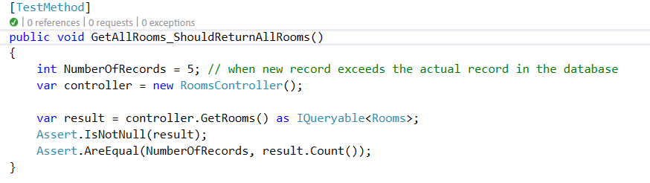

Expected Result:
It will pass because there are only 5 records inside the database.

Actual Result:
Passed:
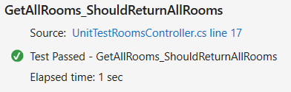

Test Case 2: Check if it can retrieve a specific room with a valid Id.

Pre-Condition: User has already created and entered all the room details into the database.

Test Step:
- Launch Application
- Enter Test Method
- Click on “Run”
Test Data:
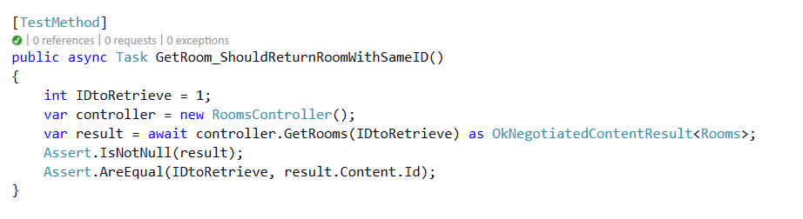
Expected Result:
It will succeed because there is a room in the database where the ID is “1”.

Actual Result:
Succeed:
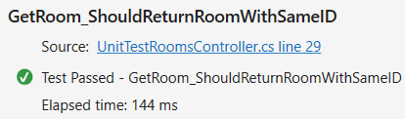

Test Scenario 2: Check Delete Functionality
Test Case 1: Check if it can delete a specific room with a valid id.

Pre-Condition: User has already created and entered all the room details into the database.

Test Step:
- Launch Application
- Enter Test Method
- Click on “Run”
Test Data:
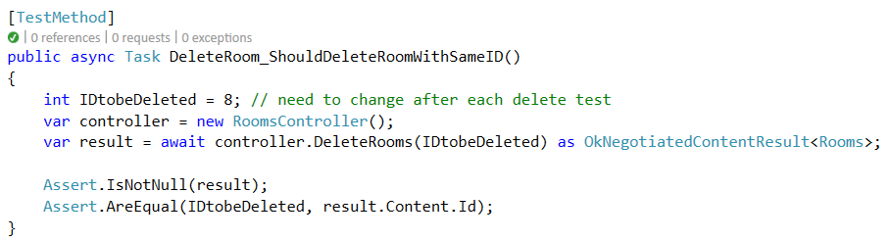

Expected Result:
It will succeed deleting the room with an ID “8” because this room exists in the database.

Actual Result:
Succeed:
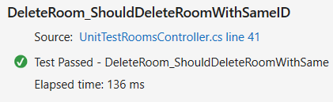

Test Case 2: Check if it can delete a room with invalid Id.

Pre-Condition: User has already created and entered all the room details into the database.
Test Step:
- Launch Application
- Enter Test Method
- Click on “Run”
Test Data:
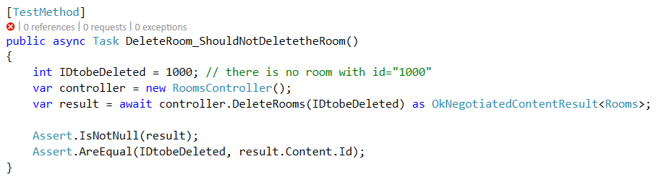

Expected Result:
It will fail because there is no room in the database where ID is “1000”.

Actual Result:
Failed:
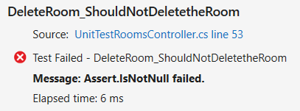

Housekeeping and Staff Management
The Process of this Development have been kept easy to the team as we also have other assignments to manage in the meantime. However, we will nonetheless meet up to discuss on our progress on a weekly basis.

For this Module in particular, I’m in charge of doing CRUD functions regarding the staff, management, receptionist as well as admin. Through this development, I’ve heavily relied on MVC models to allow different modification of data for different privilege levels. This piece of module will allow the admin and management to make changes to the Staffs, however, with Receptionist being on the lowest level, they will not be able to make modification unless they take on other roles. They will however, be able to retrieve the staff list to see the duties for the day. These CRUD are in-charged by the HouseKeeping Controller.

During this process, I’ve added quite a multitude of data for testing as well as models for entities referencing. I’ve made a variety of changes to the database, and route configurations, the layout designs, the Staff models as well as the addition of entity framework model to aid the data dispersal and arrangement to the webpages. Many modification have been made to allow the flow of such processes of CRUD by the users.

It is wise to also note that the team have agreed to also put staff’s data together into the guest table as well, since it’s a first piece of software, which we’re also incorporating the login functions for the guest later after we are able to deploy the website online, for further future implementation as mentioned by Mr Wang. However, the Staffs and Guest will be separated with their roles through another table, hence, this will be able to distinguish between them in the list for any SQL commands to be made.

With the ability to update, the staff will not be able to change their password, the reason behind this is because we plan to add an email reset password module for them, since the technicians/admin might not be around all the time.

This is a future investment as well as for our next few iterations. So technically, the guest and the staff will be accessing and logging in through the same design later on in the future, but as of now, since it’s only a point of entry for the company, the other functions will be authorized by role basis with functions like Read, Update and Delete according in a new restricted page.

I’ve also made the different functions for the few selected roles that could access. As you can see from the program, these codes have been added to aid the flow and functionalities of the software. With C# and RAZOR syntaxes/language, this platform of software development will allow quality software procedures and flow.

Here are a few examples of quality assurance of this module:
- You will not be able to modify the data if you’re not having a role of “Admin” or “Management”. This is the quality security assurance to be in the software as it prevents the abuse of integrity by the person.
- It also will allow the webpage management for the different roles, so for example, if the user that log on is a guest, the guest will not be able to see some of the layout CRUD functions that only the Staffs could.
- Things like when empty data is passed into the request during staff creation, they will be prompted, telling them the reason why. I.e. Password and Confirm Password does not match, or Invalid Email Address.
- When registering for an account, the fields have been further enhanced and sanitized to prevent SQL injections.

Furthermore, as we’re going with the Agile Software Development Cycle, this is technically the 1st phase of our Sprint/Iterations, so the product and module functionalities might not be very well-polished. With this in mind, if this project were to give it a little more time, we will be able to polish up all the different functionalities of these modules together, instead of this current unpolished modules. As in an Agile Software Development Life Cycle, each iterations/sprint takes up to 4~5months, not in like 6~8 days. Hence, it’s wise to note that this iteration would probably be more similar to that of a Waterfall Software Development Life Cycle.

I’ve also added unit testing functionalities for further inner testing when needed, they can be found below with a few screenshots, as well as in the solutions. All the functions are Fully Working, however, but I’ve encountered some errors whilst the connection string to the entities. It’s something to do with the .mdf that was made by visual studio update. Below are the process that I’ve managed to capture

Here is a test log of the CRUD
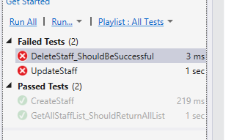

The reason for the failures are as below, but however, it’s assured that the Delete and Update staff would be successful. Since this error is brought about by the entities of LocalDB error, which I’m current unsure of how to properly troubleshoot. The TestMethod however, could be reviewed with no errors.

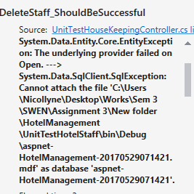

As both of them were this error, I’ve troubleshoot-ed the problem which turns out that MVC bugged out and did not store the .mdf files at the respective location. I’ve also installed ASP.NET.WEBPAGES assemblies to enable functionality. Here’s an image of a fully successfully Test Run:

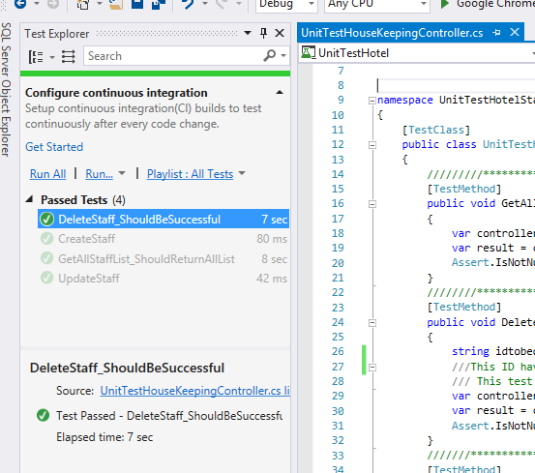

If ever you’re wondering the delay response for the Delete staff action test, it’s because there’s a need to click on a message box regarding your actions before the action ends, hence the time-delay.

Reporting Modules
The module I am in charge of is the Reporting Module. This module requires me to create and integrate 5 different types of report controllers that allows the user to use CRUD to each and every one of them, which is Create, Retrieve, Update and Delete.
The 5 different types of reports required are Room Status Report, Single Room Occupancy Report, All Room Occupant Report, Room Occupancy Report and Housekeeping Report.
The very first thing I did is to create the database for the Reporting Module which include the table and data for each of the 5 reports. After the tables were created, I added sample data into everyone one of the table, according to the correct type of data that should be entered in the correct column. The database for the reporting module is then successfully created.

What I did next was to create a new model in the software solution which is my reporting module’s model. This model will be linked to the newly created report database. Once the model was created, I then added scaffold items for each and every one of the 5 types of reports which will create a controller and 5 views for each of them including create.cshtml, edit.cshtml, delete.cshtml, details.cshtml and index.cshtml. This is a very important step as the controller will be the one that allows the users to perform CRUD on the reports.
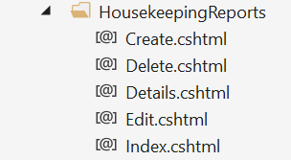
After the controllers and the views for all 5 types of reports are successfully created as shown in the above picture, it is time to edit the user interface of the views.
Our group decided to stick to the same themes and colours for the UI throughout the whole program to keep it consistent.
Once the view is successfully edited, it is time to test the CRUD of the reports. The first tests will be manual testing, which means I will run the website and test the CRUD by each of the respective buttons, checking whether a new set of data has be successfully created, updated or deleted in the database as well.
Once manual testing is done, it is time for unit testing in visual studios. Unit testing also tests the CRUD of each of the 5 report’s controllers.
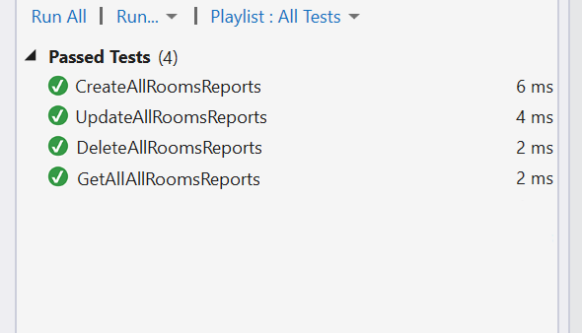
When the unit test is successfully, the reporting module is successfully created and tested for.

SYSTEM INTEGATION
We actually follow the model of Incremental testing, where we then add up the pieces of the module slowly into one as a compilation when we meet up whilst within one iteration in the Agile Software Development Life Cycle. Everyone will make sure that they tested their functionalities before compiling together as one working copy. So for me, I’ve made sure that the Delete, Update, Create and Read modules for the staff are working fine before integrating into one person’s laptop. This is also true for our other teammate who are also working to integrate into the solution later on.

Since this is only the first iteration, the modules, as mentioned, is not as well polished. We actually do manual integration ourselves through meet-ups, as everyone will make sure that they have took notes of what their code have been adjusted (i.e. they have made adjustments to this page/controller and jot them down on a document), so as to make the compilation faster. We sure that we Commented on the coding occasionally to make sure that it’s readable and scan-able. We will add the modules one by one into one working copy, after each additional module, we will make a test run to see if they all work together before moving on to add the next one.

The reason why GitHub was not exactly used is because we are following Agile Software Development Lifecycle as we have a lot of meet-ups and we have to work closely. However, we only use GitHub to upload our projects after we’re done with a major milestone as planned on the project schedule. It acts as a sort of backup. Since on each of our meet-up, we make sure that we will follow Incremental Integration into our ultimate solution on our team mate’s laptop.

This incremental Integration is easier done physically with all our team members around as they can check and discuss physically, instead of using GitHub, which could otherwise stall out a lot of time, for things like people with slow laptops and different schedules for their work. Coming to a common ground when settling this complication is like setting a date for all the members to meet up and do integration and basic progress checks, this facilitates the discussion as well as the team’s objective when working towards the goal during this software development. Hence, precisely why the reason that even GitHub brings about Convenience, it does not necessarily translate to Efficiency.

TEST LOG

Kenji Leong – Room Availability and Booking Module

Successfully register account for Guest
S/No | Steps | Test Data | Expected Results | Actual Results | Remarks
1 | Login | Username, Password | Pass | Pass | Login functionality works
2 | Select “Admin Panel” at the homepage |  | Admin Panel should appear | Admin Panel appear
3 | Select “Add Guest” |  | Register Page for Guest should appear | Register Page for Guest appear
4 | Admin enters details | UserName, Password, First Name, Last Name, Home and Email Address | Pass | Pass | A “Successfully Register Guest” message will appear

Alternate Flow 1 – Fail to register an account for guest
S/No | Steps | Test Data | Expected Results | Actual Results | Remarks
A1 | Login | Username, Password | Pass | Pass | Login functionality works
A2 | Select “Admin Panel” at the homepage |  | Admin Panel should appear | Admin Panel appeared
A3 | Select “Add Guest” |  | Register Page for Guest should appear | Register Page for Guest appear
A4 | Admin enters  Invalid data types for the password | No symbol included in the password | Fail  Error Message should appear | Fail  Error Message appeared indicating that an symbol is required | Error message works

Successfully Check in Guest
S/No | Steps | Test Data | Expected Results | Actual Results | Remarks
1 | Login | Username, Password | Pass and Return to Homepage | Return to Homepage | Login functionality works
2 | Select “Admin Panel” at the homepage |  | Admin Panel should appear | Admin Panel appeared
3 | Select “Check-in” |  | Check-in Page should appear | Check-in Page appeared
4 | Admin enters valid check in details | Check-in Details  -Check in and out Date  -Room Number  and Types,  -Guest ID  -Password  -First and Last Name,  -Number of Adults and Children  - Home and Email Address  - Phone number  Payment Details  -Payment Types  -Card number  -Expiry  -Transaction Date | Pass | Pass | A “Successfully added” message will appear

Successfully Retrieve Guest Details
S/No | Steps | Test Data | Expected Results | Actual Results | Remarks
1 | Login | Username, Password | Pass | Pass | Login functionality works
2 | Select “Admin Panel” at the homepage |  | Admin Panel should appear | Admin Panel appeared
3 | Select “Guest List” |  | Guest List page should appear | Guest List page appeared
4 | Admin should be able to see all the guest details | Guest ID, First Name, Last Name,  Number of Adults and Children,  Home and Email Address, Payment Type,  Room number,  Room Types | Pass  Should be able to retrieve all this details | Pass  All the data is shown | Retrieving of guest list details works

Successfully Update Guest Details
S/No | Steps | Test Data | Expected Results | Actual Results | Remarks
1 | Admin Logs into the Guest Account | Username, Password | Pass | Pass | Login functionality works
2 | Clicks on the username at the homepage |  | Profile Page should appear | Profile Page appeared
3 | Select “Update Guest List Details Profile” |  | Update Guest List page should appear | Update Guest List page appeared
4 | Admin enters new Username | Username with valid data types such as minimum of 2 letters | Pass  Should Redirect to profile page | Pass  Redirect to profile page | Update guest details works

Successfully Retrieve Payment Details
S/No | Steps | Test Data | Expected Results | Actual Results | Remarks
1 | Login | Username, Password | Pass | Pass | Login functionality works
2 | Select “Admin Panel” at the homepage |  | Admin Panel should appear | Admin Panel appeared
3 | Select “Payment Details” |  | Payment Details page should appear | Payment Details page appeared
4 | Admin should be able to see all the payment details | Guest ID,  Payment Type,  Total Amount, Card Number,  Expiry Date,  Date of Transaction | Pass  Should be able to retrieve all this details | Pass  All the data is shown | Retrieving of payment list details works

Successfully Retrieve Feedback
S/No | Steps | Test Data | Expected Results | Actual Results | Remarks
1 | Login | Username, Password | Pass | Pass | Login functionality works
2 | Select “Admin Panel” at the homepage |  | Admin Panel should appear | Admin Panel appeared
3 | Select “Feedback List” |  | Feedback List page should appear | Feedback List appeared
4 | Admin should be able to see all the feedback from all the guests | Guest ID,  Comment | Pass  Should be able to retrieve all this details | Pass  All the data is shown | Retrieving of feedback list works

Successfully Retrieve Room List
S/No | Steps | Test Data | Expected Results | Actual Results | Remarks
1 | Login | Username, Password | Pass | Pass | Login functionality works
2 | Select “Admin Panel” at the homepage |  | Admin Panel should appear | Admin Panel appeared
3 | Select “Room List” |  | Room List page should appear | Room List appeared
4 | Admin should be able to see all the rooms details | Room ID,  Image,  Room Number,  Room Types,  Room Status,  Price,  MaxAdults,  MaxChildren,  Description, | Pass  Should be able to retrieve all this details | Pass  All the data is shown | Retrieving of Room list details works

Successfully Add Room
S/No | Steps | Test Data | Expected Results | Actual Results | Remarks
1 | Login | Username, Password | Pass | Pass | Login functionality works
2 | Select “Admin Panel” at the homepage |  | Admin Panel should appear | Admin Panel appeared
3 | Select “Room List” |  | Room List page should appear | Room List appeared
4 | Admin click on the “Create” button |  | Create Page should appear | Create Page appeared
5 | Admin enters valid datatypes for all columns | Room ID,  Cover Image,  Room Number,  Room Types,  Room Status,  Price,  MaxAdults,  MaxChildren,  Description
6 | Admin clicks on the “Confirm button” |  | Pass  A message should appear | Pass  A message called “Record Successfully” appeared | Create room functionality works

Successfully Update Room
S/No | Steps | Test Data | Expected Results | Actual Results | Remarks
1 | Login | Username, Password | Pass | Pass | Login functionality works
2 | Select “Admin Panel” at the homepage |  | Admin Panel should appear | Admin Panel appeared
3 | Select “Room List” |  | Room List page should appear | Room List appeared
4 | Admins click on the “Edit” button for the room they want to edit |  | A modal to edit the room details should appear | The modal to edit the room details appeared
5 | Admin enters Room ID | Room ID with valid datatypes such as Integer
6 | Admin clicks on the “Confirm button” |  | Pass  A message should appear | Pass  A message called “Update Successfully” appeared | Update room functionality works

Successfully Delete Room
S/No | Steps | Test Data | Expected Results | Actual Results | Remarks
1 | Login | Username, Password | Pass | Pass | Login functionality works
2 | Select “Admin Panel” at the homepage |  | Admin Panel should appear | Admin Panel appeared
3 | Select “Room List” |  | Room List page should appear | Room List appeared
4 | Admins click on the “Edit” button for the room they want to edit |  | A modal to edit the room details should appear | The modal to edit the room details appeared
5 | Admin clicks on the “Delete button” |  | Pass  A message should appear | Pass  A message called “Deleted Successfully” appeared | Delete functionality works

Jia Cheng – CRUD for Housekeeping and Staff Management Module

FLOW OF EVENTS: Registering an account

Basic Flow:

Registering an Account

This use case is when the user/staff have accesses the software and wants to create a new account so as to access the webpage and staff component

Their information will be asked for, like <Insert Information>, to register an account

Successfully Created an Account

Alternative Flow:

A1) Password and Confirm Password does not match

The two password field does not match, particularly, the Password field and the Confirm Password field.

A2) Invalid Email address

The values used in the Email field is invalid or illegal, i.e. they should follow email syntaxes like 123@gmail.com instead of DROP TABLE USER, which is to prevent SQL injection

Scenarios:

Registering
Scenario Name | Starting Flow | Alternate
Scenario 1: Successfully Registered | Basic Flow
Scenario 2: Password and Confirm Password does not match | Basic Flow | A1
Scenario 3: Invalid Email Address | Basic Flow | A2

Test Cases:

Registering
ID | Scenarios | First Name | Last Name | User Name | Email | Home Address | Password | Confirm Password | Expected Results
1 | Successful Registration | Valid | Valid | Valid | Valid | Valid | Valid | Valid | Brings user to homepage
2 | Password did not match with Confirm Password | Valid | Valid | Valid | Valid | Valid | Valid | Invalid | Brought back to the same page and prompted of error
3 | Invalid Email Address | Valid | Valid | Valid | Invalid | Valid | Valid | Valid | Brought to the same page and prompted of error

Test Data:

Registering
ID | Scenarios | First Name | Last Name | User Name | Email | Home Address | Password | Confirm Password | Expected Results
1 | Successful Registration | Johnny | Tan | Johnny123 | 123 @  gmail.com | Block 123 | Password | Password | Brings user to homepage
2 | Password did not match with Confirm Password | Johnny | Tan | Johnny123 | 123 @ gmai.com | Block 123 | Password | Donkey | Prompted of mismatch in those two fields
3 | Invalid Email Address | Johnny | Tan | Johnny123 | Email.com | Block 123 | Password | Password | Prompted of the invalid email

FLOW OF EVENTS: Logging In

Basic Flow:

Logging in with an account

Page requests for their UserName and Password

They will then log in with their credentials keyed

Successfully Logged on

Alternative Flow:

A1) Username does not match with Password does not exist

Cannot find both data that was keyed by the user in the table

A2) Password does not match with User Name

Cannot find both data that was keyed by the user in the table

Test Scenario:

Logging in
Scenario Name | Starting Flow | Alternate
Scenario 1: Successfully Logged In | Basic Flow
Scenario 2: Invalid Login Attempt | Basic Flow | A1 / A2

Test Cases:

Logging In
ID | Scenarios | User Name | Password | Expected Results
1 | Logged In Successfully | Valid | Valid | Brings user to homepage
2 | User Name does not exist | Invalid | Valid | Brought back to the same page and prompted of invalid login
3 | Password did not match with Database of the Username | Valid | Invalid | Brought to the same page and prompted of invalid login

Test Data:
ID | Scenarios | User Name | Password | Expected Results
1 | Logged In Successfully | Miku | Password123! | Brings user to homepage
2 | User Name and Password found no match in the database | alshfdskjfh | Password123! | Brought back to the same page and prompted of invalid login
3 | User Name and Password found no match in the database | Miku | dfdkfdk | Brought to the same page and prompted of invalid login

FLOW OF EVENT: Deleting a staff account

Basic Flow:

Choose an account to delete

Admin/Management Role will have the ability to do this, they will select and delete off from their list

Successfully deleted

Alternative Flow:

A1) Account does not exist in the database

The page did not manage to update in time (Doesn’t actually happen, but just in case)

Test Scenario:

Deleting Account
Scenario Name | Starting Flow | Alternate
Scenario 1: Successfully Deleted the account | Basic Flow
Scenario 2: Unable to delete account | Basic Flow | A1

Test Cases:

Deleting Account
ID | Scenarios | Delete Pressed | Expected Results
1 | Account Deleted Successfully | Valid | Be prompted with a notification of successful account deletion and brings user back to stafflist page
2 | Unable to delete account as account does not exist | Valid | Brought back to the same page, with the page being refreshed, and having that account that was not removed previously removed

Test Data

Deleting Account
ID | Scenarios | Delete Pressed | Expected Results
1 | Account Deleted Successfully | Delete Icon pressed by user | Be prompted with a notification of successful account deletion and brings user back to stafflist page
2 | Unable to delete account as account does not exist | Delete Icon pressed by user | Brought back to the same page, with the page being refreshed, and having that account that was not removed previously removed

FLOW OF EVENT: Editing the Data of the Staff

Basic Flow:

Choose an account to edit

Admin/Management Role will have the ability to do this, they will select and edit their information in another page

Brings the user to another page

Keys in the different information to be edited, which includes User Name, First Name, Last Name, Email, DOB, Credit Card Number, Home Address, Home Address, Phone Number, Duty Types

User saves the edited information

Changes made to the database successfully

Alternative Flow:

A1) User Decides press Back to Staff List

User decided not to edit this profile, hence it is a button to move the user back

Scenarios:

Editing
Scenario Name | Starting Flow | Alternate
Scenario 1: Successfully Edited | Basic Flow
Scenario 2: User presses back | Basic Flow | A1

Test Cases:

Editing
ID | Scenarios | First Name | Last Name | User Name | DOB | Credit Card Number | Email | Home Address | Password | Confirm Password | Duty Types | Expected Results
1 | Successful Editing | Valid | Valid | Valid | Valid | Valid | Valid | Valid | Valid | Valid | Valid | Notification prompts the user about success and brought back to Stafflist page
2 | User Presses Back | Valid | Valid | Valid | Valid | Valid | Valid | Valid | Valid | Valid | Valid | Brought back to the Stafflist page

Test Data:

Editing
ID | Scenarios | First Name | Last Name | User Name | DOB | Credit Card Number | Email | Home Address | Password | Confirm Password | Duty Types | Expected Results
1 | Successful Editing | Sean | Wei | SW | 10/06  /1970 | 123-58657-123 | 123@  gmail  .com | Block 233 | Password  123! | Password  123! | Room  Mainte  -ance | Notification prompts the user about success and brought back to Stafflist page
2 | User Presses Back | Sean | Wei | SW | 10/06  /1970 | 123-58657-123 | 123@  gmail  .com | Block 233 | Password  123! | Password  123! | Room  Mainte  -ance | Brought back to the Stafflist page

Mao Cheng – Reporting Modules

Create All Rooms Reports

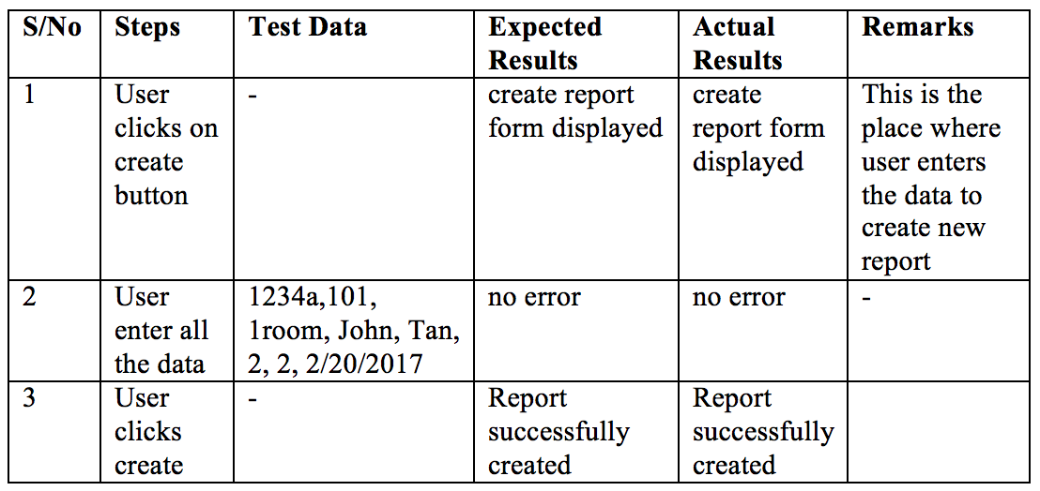

Step 1: Generate Scenarios

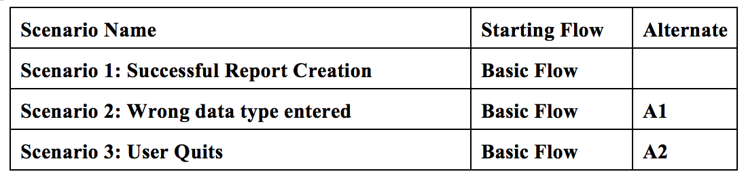

Step 2: Identify Test Cases

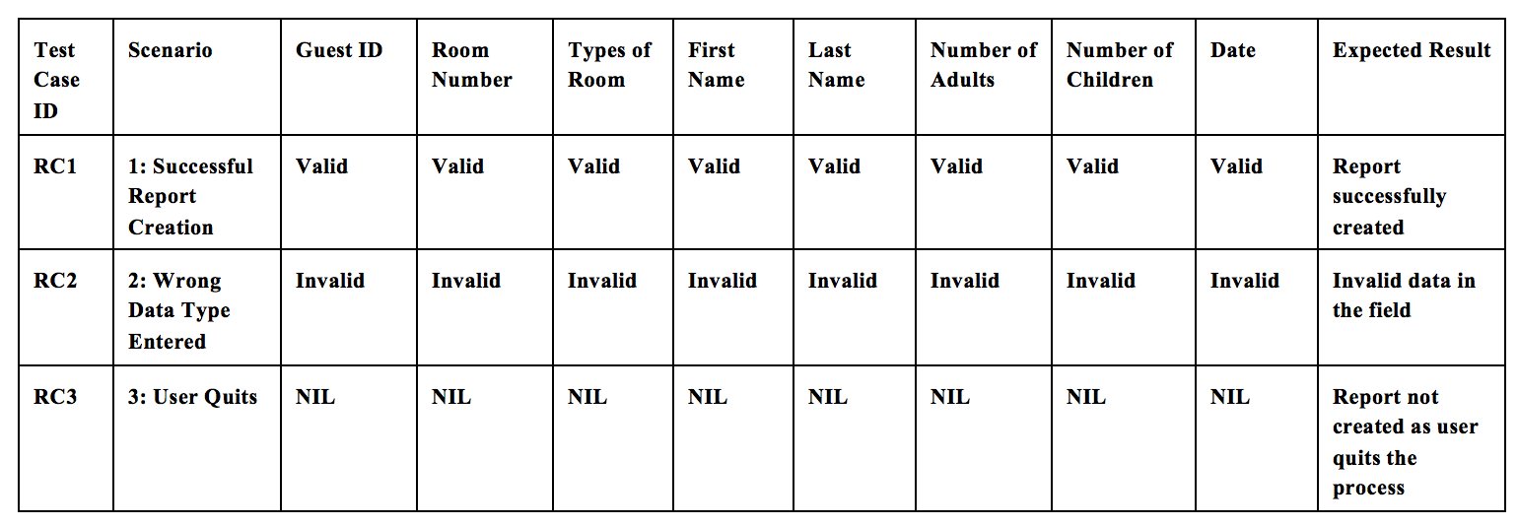

Step 3: Identify Test Data

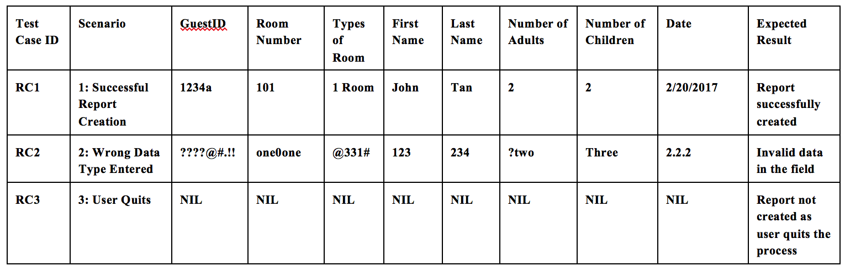

Update All Rooms Reports

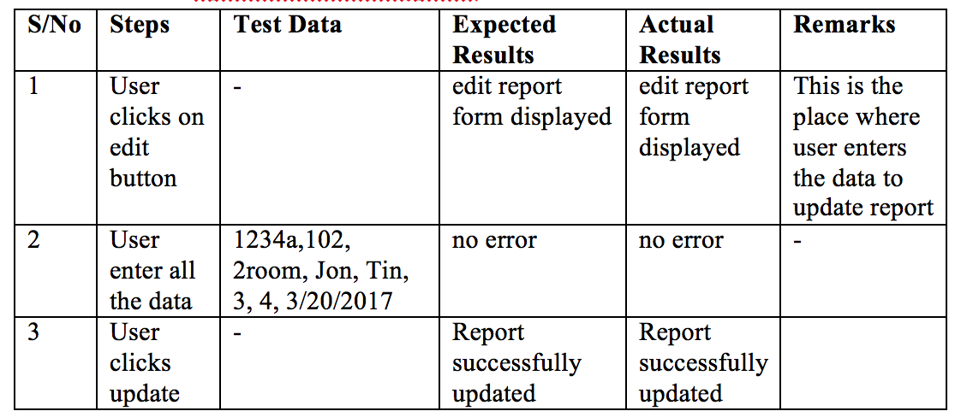
Step 1: Generate Scenarios

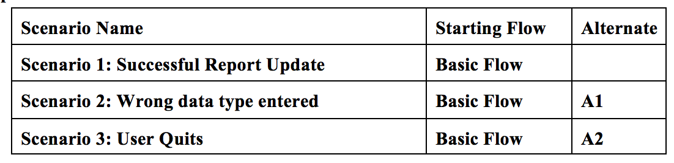
Step 2: Identify Test Cases
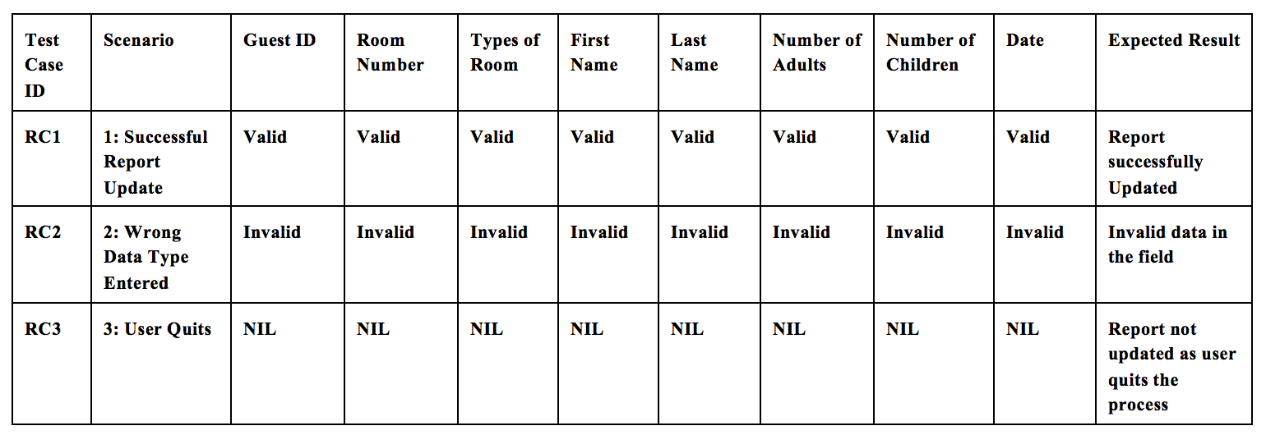

Step 3: Identify Test Data
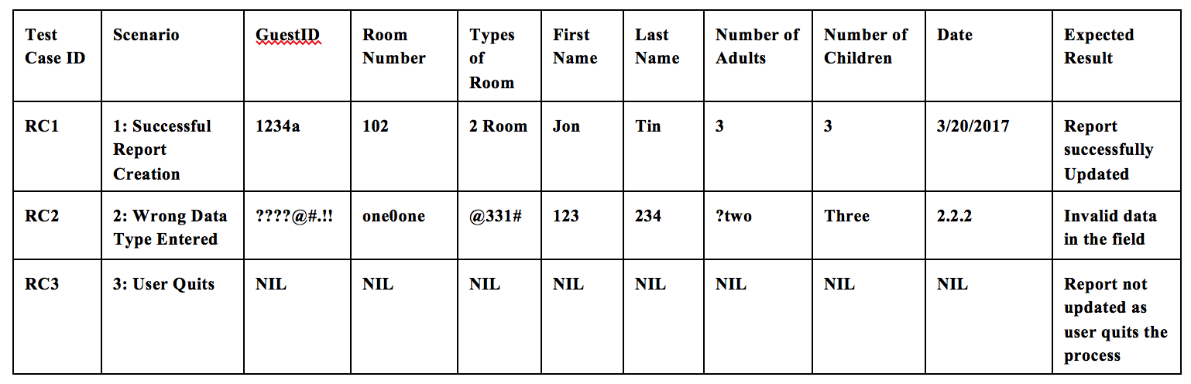

Delete All Rooms Reports

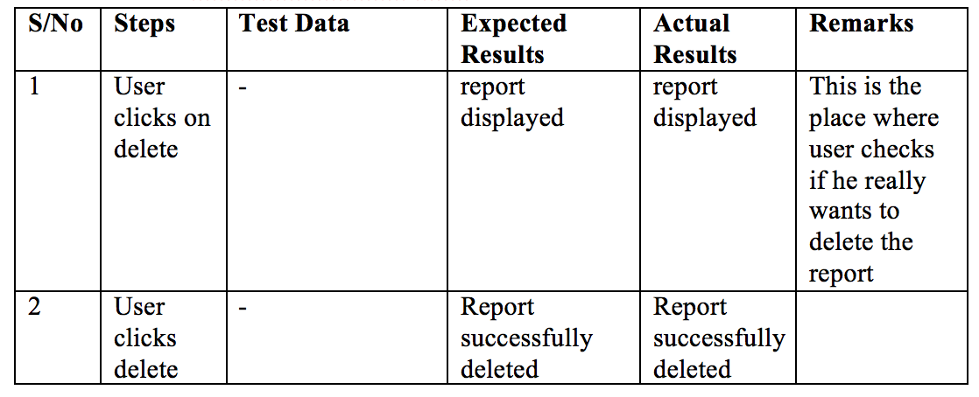
Step 1: Generate Scenarios
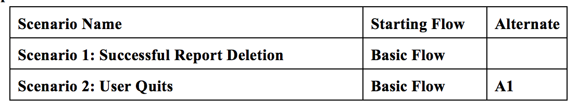

Step 2: Identify Test Cases
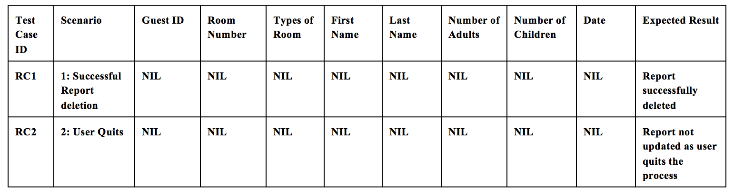

Step 3: Identify Test Data
